**Example: Dream Team Formation**

Coach Brey is faced with the decision of selecting 7 star players for the Dream Team. He has narrowed his choice down to 10 players. For each player, Coach Brey has collected some statistics (1 being best, and 5 being worst) for the players. In addition, players can only play certain positions of the lineup. The positions that each player is allowed to play and the player’s assists, scoring, rebound and defense skills are listed in the table below.



In order to have a well-rounded team, the coach knows he must fulfill the following requirements:

1. At least two members must be able to play guard (G), at least four members must be able to play forward (F), and at least two players must be able to play center (C) (some players have to be versatile).
2. The average assists, rebounding, and defense level of the 7 star players must be better than 4. (Keep in mind, 1 is best and 5 is worst)
3. If player 4 is on the team, then player 5 cannot be on the team (Players have compatibility issues!).
4. Players 3 and 9 must be selected together because they feel they are most effective when they play together (so either both or neither are selected).
5. Either player 3 or player 4 (or both) must be included because they are the ones that bring in the fans.

Given these constraints, Coach Brey wants to maximize the total scoring ability of the Dream team. Who should be in the dream team?

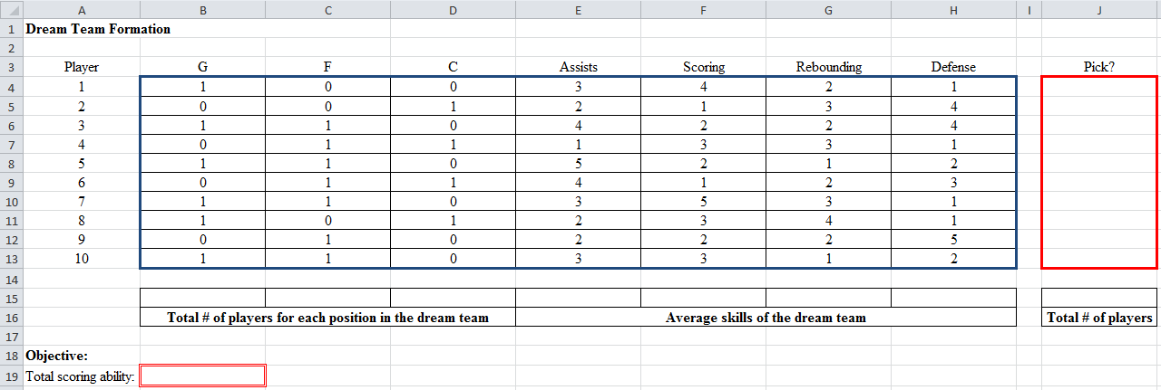**Excel Setup:**

=sumproduct(F4:F13,J4:J13)

=sumproduct(E4:E13,$J4:$J13)/7

=sum(J4:J13)

=sumproduct(B4:B13,$J4:$J13)

**Specify Solver:**

Set Objective: B19

To: ○ Max X Min ○ Value of: _________

By Changing Variable Cells: J4:J13

Subject to the Constraints:

|  |
| --- |
| 2 guards: B15>=2  4 forwards: C15>=4  2 centers: D15>=2  Average assists better than 4: E15<=4  Average rebounding better than 4: G15<=4  Average defense better than 4: H15<=4  4 & 5 can’t be both in: J7+J8<=1  3 & 9 together: J6=J12  3, or 4, or both: J6+J7>=1  J4:J13=binary  J15=7 |

□ Make Unconstrained Variables Non-Negative (*doesn’t matter*)

Select a Solving Method: Simplex LP

**Solution:**

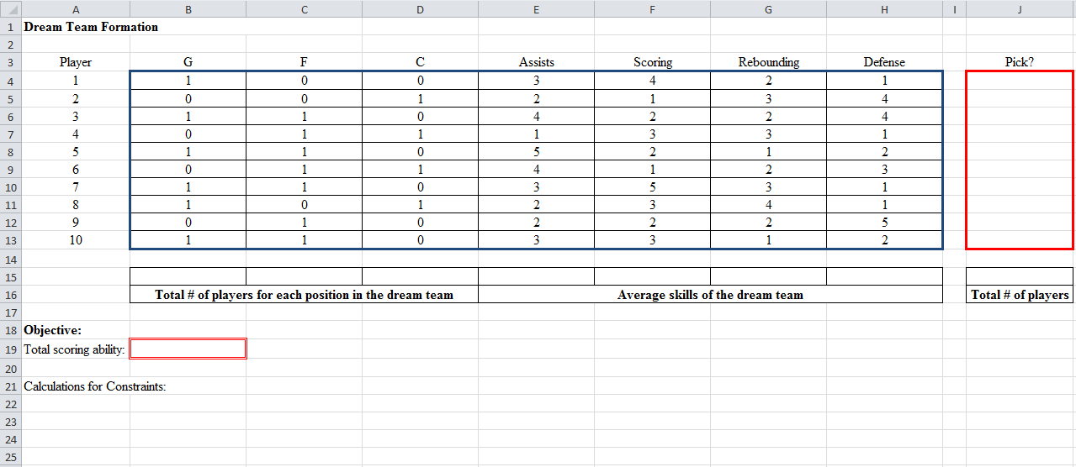

14

Players 4&5: =J7+J8

Players 3&4: =J6+J7

0

1

1

0

1

1

0

1

1

1